**SECTION A (60 Marks)**

Answer only **three** questions from this section.

1. (a) State:
2. Partition law. (01 mark)
3. **Three** limitation of partition law. (01½ marks)
4. Describe how the partition coefficient for butane-1,4-dioic acid between trichloromethane and water can be determined. (06 marks)
5. In an experiment, an aqueous solution containing 4.0 g of butane-1,4-dioic acid dissolved in 1 dm3 to of solution was shaken with 200cm3 of trichloromethane. Calculate the percentage by mass of butane-1,4-dioic acid that remained in the aqueous layer. (The partition coefficient between trichloromethane and water = 22.5) (03½ marks)
6. (i) Define the term **steam distillation.** (01 mark)

(ii)State **three** principles of steam distillation. (03 marks) (iii) A mixture of phenylamine and water was steam distilled at 98oC and 101.325 kPa. The saturated vapour pressure of water at 98oC is 96.000 kPa. Calculate the percentage of by mass of phenylamine in the distillate. (03 marks)

1. Explain the trend in the boiling points of group VII elements. (03 marks)
2. Explain why hydrogen fluoride:
3. Is a weaker acid in a dilute aqueous solution than in a concentrated solution? (03 marks)
4. Has a higher boiling than hydrogen iodide. (03 marks)
5. Write the equation for the reaction between hydrogen fluoride and silicon (IV) oxide. (01 mark)
6. Describe the reactions of group VII elements with sodium hydroxide. (07 marks)
7. Write the equation for the reaction between sulphuric acid and
8. Sodium chloride. (01 mark)
9. Potassium bromide. (01 mark)
10. Sodium iodide. (01 mark)
11. A compound **Z** contains 73.32% by mass carbon, 6.38% by mass hydrogen and the rest being oxygen. When 1.5 g of **Z** was dissolved in 20.9 g of benzene, the resultant solution froze at 1.3oC. Pure benzene freezes at 5.50oC. (K*f* of benzene is 5.49oC mol-1kg-1)
12. Determine:
13. the empirical formula of **Z**. (01½ marks)
14. the molecular formula of **Z**. (02½ marks)
15. (i)Write the structural formula of **Z**. (0½ mark) (ii)Explain why an aqueous solution of **Z** turns blue litmus pink. (02 marks)
16. Write equation to show how **Z** can be:
17. Prepared from benzene. (03 marks)
18. Converted to methycyclohexane. (03 marks)
19. Write equation and outline the mechanism for the reaction between **Z** and ethyonylchloride in the presence of aqueous sodium hydroxide solution. (03 marks)
20. Name a reagent that when separately added to both **Z** and ethanol
21. Gives similar observation. (01½ marks)
22. Can be used to differentiate between the two compounds. (02 marks)

(In each case state what would be observed)

1. (a) Distinguish between:
2. **Electrolytic conductivity** and **molar conductivity**. (02 marks)
3. **Ionization** and **dissociation**. (02 marks)
4. State the relationship between the two conductivities in (a) (i). (01 mark)
5. (i) Sketch a graph to show how the molar conductivity of sodium ethanoate varies with dilution. (02 marks)
6. Explain the shape of the graph. (03 marks)
7. The table shows the molar conductivity of an aqueous solution of a weak acid HA at 25oC.

|  |  |  |  |
| --- | --- | --- | --- |
| Concentration of acid, HA [mol/ℓ] | 0.001 | 0.01 | 0.1 |
| Molar conductivity [Scm2/mol] | 50 | 16 | 5 |

1. Explain the trend in molar conductivity. (02 marks)
2. Calculate the pH and hence the ionization constant, Ka of 0.01 M solution of the weak acid, HA. (The molar conductivity at infinite dilution of the weak acid is 390Scm2mol-1) (04½ marks)

(e) The following standard electrode potentials at 25oC.

Pb2+(aq) + 2e- → Pb(s), Eθ = −0.126𝑉

Zn2+(aq) + 2e- → Zn(s), Eθ = −0.763𝑉

1. Write the overall cell reaction and hence the cell diagram. (02 marks)
2. Calculate the maximum energy obtained from the cell. (01½ marks)

**SECTION B (40 Marks)**

Answer only **two** questions from this section.

1. (a) Define the terms: (@01 mark)
2. **Relative atomic mass.**
3. **Isotopes.**
4. A naturally occurring element Q has two isotopes, 20𝑄 and 22𝑄. The relative atomic mass of Q is 20.2.
5. Briefly describe how the mass spectrometer can be used to obtain the relative atomic mass of Q. [*No diagram required*] (06 marks)
6. Calculate the relative abundances of the different isotopes of Q. (03 marks)
7. State:
8. **two** uses of isotopes. (02 marks)
9. **one** limitation in using mass spectrometer for relative atomic mass determination. (01 mark)
10. One of the reasons why isotopes of elements undergo radioactive decay is to achieve stability in the nuclei. The graph in figure 1 shows a plot of number of neutrons against number of protons for stable nuclei.



State:

1. **Two** factors that determine the stability of a nucleus of an atom. (01 mark)
2. What line A represents. (0½ mark)
3. What region B represents. (0½ mark)
4. Briefly describe how isotopes in regions 1 and 2 in Figure 1 can achieve stability. (04 marks)
5. Write equations to show how the following compounds can be synthesized. Indicate the reagents and conditions.
6. Nitrobenzene to methylbenzene. (04 marks)
7. Benzene to phenylmethanal (benzaldehyde) (04½ marks)
8. Propan-2-ol to 1-aminopropane. (04 marks)
9. Methylbenzoate to hydroxybenzene. (04½ marks)
10. Iodoethane to N-methylpropylamine. (03 marks)
11. (a).Describe how:
12. Pure copper can be extracted from copper pyrites. (10 marks)
13. Copper reacts with sulphuric acid. (03 marks)

(Your answers show should include equations for the relevant reactions)

1. State what would be observed and write equation for the reaction that would take place if an aqueous copper (II) sulphate solution was treated with:
2. Potassium hydrogencarbonate solution. (02 marks)
3. Excess potassium iodide solution. (03 marks)
4. Compounds of copper (I) are colourless while copper (II) are either blue or green. [*Atomic number of copper is 29*] (02 marks)
5. Explain each of the following observations and where applicable illustrate your answer with equation(s).
6. The relative molecular mass of aluminium chloride determined by a method of depression of freezing point of benzene was found to be 267. (03 marks)
7. 1-bromohexane undergoes nucleophilic substitution reaction whereas bromobenzene does not. (05 marks)
8. When excess dilute sulphuric acid was added to potassium chromate (VI) solution, the yellow solution turned to orange. Addtion of few drops of hydrogen peroxide to the resultant solution gave a deep blue solution. (04 marks)
9. The melting of 4-nitrophenol is higher than that of 2-nitrophenol. (05 marks)
10. The ionic conductivities of rubidium and sodium ions are 78.3 and 50.1Scm2mol-1. (03 marks)

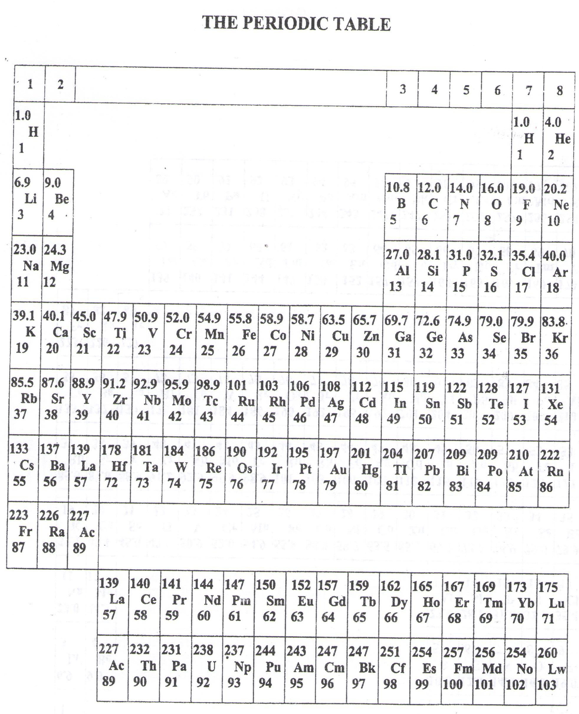

* ===END===

WELCOME TO SENIOR SIX, YEAR 2023

This is the last page of the printed paper, Page 06